John Perry

1958 – 2024

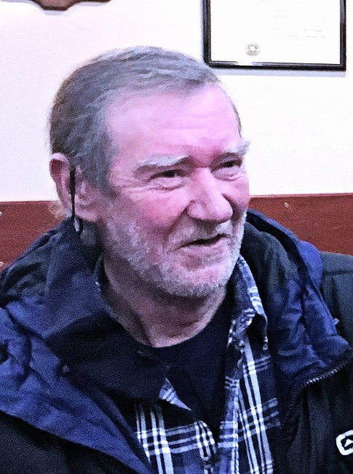It is with deep regret that we announce the passing of John Perry on the 26th of March 2024. John was a long-time member of ANAVETS Sidney Unit 302 from 2005 – 2007 and rejoined the Unit in 2024. Back in the 1990’s John was into darts and recently continued to drop in on Sundays to have a game with brother Steve while long time companion Cathy Barker played bingo.

Obit by Cathy Barker

July 15, 1958 - March 26, 2024

We are sad to announce the passing of John Perry

John was born and raised in Sidney B.C. He loved golfing, fishing, playing pool and darts with his friends & family, as well as a good game of crib.

His biggest love of all was being on the ocean fishing, rod in hand.

He was predeceased by his father Herb, his mother Vera stepfather Rick Kent, Siblings Diana, Ray and Roger

He is survived by, His longtime Companion Cathy Barker (Hadden), his son Jason Gust Siblings: Elaine Bompas ( Al), Carol Travis (Larry), Susan Criddle(Perry), Steven, and Donna Perry Wooton (Al), and many nieces and nephews.

John will be sadly missed by all. Cremation has taken place.

A private family gathering will take place at a later date.