Helen Watt

1935 – 2024

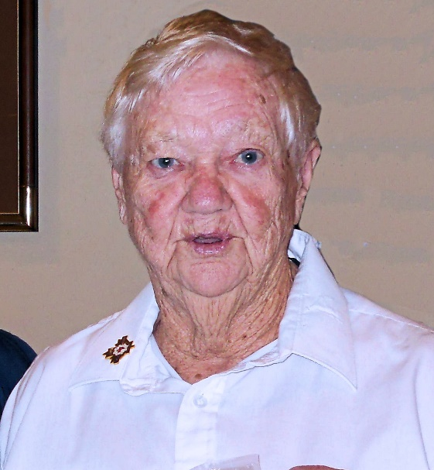Comrades

It is with deep regret that we announce the passing of Helen Watt on January 1, 2024. Helen was an Associate member first joining the ANAVETS Sidney Museum Unit 302 in 1976 as Helen Styan and, became president of the Ladies Auxiliary in 1982 and 1983. She also served on the Ladies Auxiliary as Helen Watt in the roll of Sick and Visiting for seven years 2007 – 2014. Most recently Helen could be seen at the Sunday bingos enjoying the afternoon with longtime friends.

A Celebration of Life will be held in the Unit on the afternoon of Saturday, February 3rd, 2024 between the hours of 1 – 3 PM